User Manual: Quote Requests

| july-20 |

**Document Overview**

**Documentation Goals**

This documentation is intended to provide instruction for all ***Request for Quotes*** functions*.* It details the use of ***Add and Altering Customer Quote Requests*** and maintaining the ***Quote Request File Management System***.

**Documentation Disclaimers**

* Teach a user how to utilize Quote Request system.
* Provide instructions for setting up customer quote requests, as well as altering or keeping them up to date.

**Table of Contents**

**Overview of Advantzware Specific Keys and Icons** 4

Function Keys 4

Advanced Software Standard Function Keys 5

Program Icons 6

**Request for Quotes [QR]** 7

Overview 7

Browse Part Number 8

Overview 8

Browse Part Number Screen 9

View RFQ 11

Overview 11

View RFQ Screen 12

Add/Update RFQ 13

RFQ Item 15

Overview 15

RFQ Item Screen 16

Add/Update RFQ Item 17

Set Information 19

Update Set Information 19

Size 21

Overview 21

Size Screen 21

Item Specification 23

Overview 23

Item Spec Screen 23

Update Item Spec 24

Materials 25

Overview 25

Materials Screen 25

Update Materials 26

Printing 28

Overview 28

Printing Screen 28

Update Printing Information 29

Shipping 31

Overview 31

Shipping Screen 32

Update Shipping 33

**Line Request for Quotes [QL]** 35

Overview 35

Single RFQ List [QL1] 36

RFQ List [QL2] 37

**File Maintenance for RFQ [QF]** 38

Overview 38

RFQ File Maintenance [QF1] 38

Overview 38

RFQ Maintenance Screen 39

Update RFQ File Maintenance 40

# **Overview of Advantzware Specific Keys and Icons**

## Function Keys

|  |  |
| --- | --- |
| BRWS | The browser, which is a list of records in this file. This is functionally equivalent to the Find option of our standard package. |
| VIEW | View record provides the ability to ADD, CHANGE, DELETE, and UPDATE an individual record. |
| SORT BY | The selections at the bottom of the browser, which will sort the list alphabetic order. |
|  |  |
| Update | Update the current record. |
| Reset | Reset the current record. |
| Add | Add a record. |
| Copy | This will copy the existing record. |
| Delete | Delete the current record displayed on the screen. |
| Cancel | Cancel the information that was entered. |
| Save | Save the record. |
|  |  |
|  | Takes the user to the first current record. |
|  | Moves backward one record. |
|  | Moves forward one record. |
|  | Takes the user to the last current record. |
|  |  |
| F1 | Miscellaneous Fields |
| F3 | Search |
| F3 | List |
| F4 | Notes |
| F6 | Browse |
| F7 | Viewer |
| F12 | Exit |

## Advanced Software Standard Function Keys

|  |  |
| --- | --- |
| Next | Shows the next sequential record. |
| Prev | Shows the previous record. |
| Add | Add a record. |
| Change | Change the current record displayed on the screen. |
| Delete | Delete the current record displayed on the screen. |
| Find | Find a record by searching by description. |
| “1”, “2” | Number 1 or 2 to go the first or second page of this record. |
| Esc | Escape from the current transaction without updating. |
| Q | Quit from the current transaction without updating. |
| F1 | Save |
| F3 | Help information is available on every data field. Simply place the cursor on a field and press F3 to display documentation regarding this particular field. |
| F3 | To insert additional data in a data field without erasing the information currently displayed. |
| F4 | Notes – General |
| F1 | Field Lookup is available on every data field which is maintained in a separate file. Place the cursor on a field and press ***“F1”*** to search for the code by description or to advance a screen of records by pressing the next key. Place the cursor next to the desired record and press enter to transfer the record to the data entry screen. See ***“Page Up”*** / ***“Page Down”*** keys below as an alternative |
| F7 | Delete |
| F8 | Notes – File Specific |
| Enter | Advances the cursor to the next field |
| Page Up | Will skim forward through each record in a data file in sequential order |
| Page Down | Will skim backward through each record in a data file in sequential order |
|  |  |

## Program Icons

|  |  |  |
| --- | --- | --- |
|  | Job Notes |  |
|  | Customer Attachments | Attach files (such as Word/Excel/Images) for this specific customer order. |
|  | Change Move/Set Column Mode |  |
|  | Print Acknowledgement |  |
|  | Export to Excel |  |
|  | Add |  |
|  | Attachments | Attachments for this Estimate. Will transfer to all future repeat orders for this estimate. |
|  | Notes |  |
|  | Spec Notes | Notes for specific finished goods items. |
|  | Utility Application |  |
|  | Help |  |
|  | UDF Viewer |  |
|  | Commissions |  |
|  | Exit |  |
|  |  |  |
|  |  |  |

# **Request for Quotes [QR]**

## Overview

The request for quotation module provides the ability to enter specifications for one or more jobs without knowing how the estimate will be created. When a customer sends a request for a quotation for one or more boxes, this program allows salespeople or customer service representatives the ability to enter detailed information about the customer’s requirements for the items to be manufactured. Once the data has been entered the information can be transferred to any estimate format in seconds.

If a request for quotation has many items defined, the items may be transferred to multiple estimates or may be combined together on one estimate as a combination job or as a corrugated set. This transfer logic will allow one RFQ record for several items to create both single item estimates as well as a combination estimates in seconds. In addition, the user has the ability to select which items they would like to transfer to the estimate.

This module is completely integrated with the Advantzware database information such as the customer, style, shipping carrier, raw materials, colors, blank dimensions, destination and more. Therefore, when an existing customer or part number is entered, the data from Advantzware will transfer directly to the new request for quote.

For brand new items, the information may be added as if creating a brand-new item. Once the data has been entered, this may be transferred to an estimate then the finished good item may be created automatically. Once the estimate has been created in Advantzware, the estimate number is transferred back to the request for quotation file.

## Browse Part Number

### Overview

This module has two browsers to help find a particular part number. The customer part number browser shows all the items in alphabetic order listing the customer part number as the primary sort option. To sort by the customer number, simply click the customer number field at the bottom of the browser and the list will be resorted in customer number order.

This browser shows each part number for all request for quotes showing the part number, the request date, the style, the product category, the quantity requested, number of colors, number of coatings, blank length, width and depth.

#### Customer Field

The customer field provides a search on a specific customer code to show all the estimate number for that customer. Each mouse click on the yellow fields on the browser will alternate the sort in ascending then descending order for the list of estimates displayed on the browser.

#### Customer Part Number Field

The customer part number field provides a search on a specific customer part code to show all the estimate number for that customer part number. Each mouse click on the yellow fields on the browser will alternate the sort in ascending then descending order for the list of estimates displayed on the browser.

#### Finished Good Item Name Field

The finished good item name field provides a search on a specific finished good name to show all the estimate numbers for that finished good item name. Each mouse click on the yellow fields on the browser will alternate the sort in ascending then descending order for the list of estimates displayed on the browser.

#### Customer Field

The customer field provides a search on a specific customer code to show all the estimate number for that customer. Each mouse click on the yellow fields on the browser will alternate the sort in ascending then descending order for the list of estimates displayed on the browser.

#### Fields Overview

Other fields may be added to limit the list of estimates displayed. Simply type a few letters and the list will continue to limit the estimate list by all the fields that are selected. For example, tab to the Customer field, then type ABC, click ***“Go”*** and only the customers that start with ABC will appear. In addition to the customer name, also type the style and only the estimates for that specific style and customer will appear on the browser.

To update a particular estimate, just double click the estimate line listed on the screen.

### Browse Part Number Screen

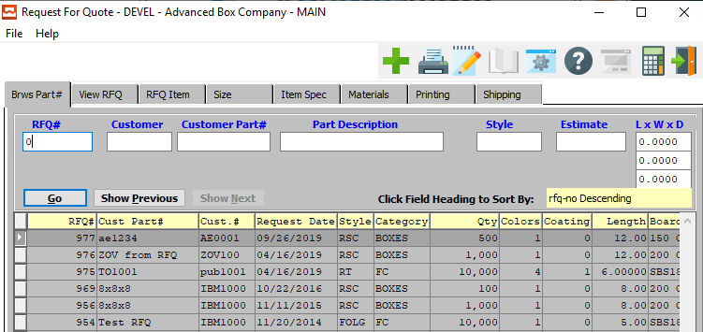

#### ADD

To add a new Quote, simply click the ***“Green + Icon”*** button at the top of the Request for Quote screen.

Alternatively, click the ***“Add”*** button at the bottom of the screen.

### Browse Part Number Field Definitions

#### Customer Code

Press the ***“F1”*** look-up key for selection or type a partial description of the customer code and click the ***“Go”*** key to list all the estimates for that customer. Press ***“F1”*** to search for a customer then the ***“F1”*** browser will allow you to search by the customer code or customer name. The ***“F1”*** browser allow typing a few letters to limit the search for any field selected on the browser. You must click the desired search field, then type the letters. Note the auto find box houses the letters that are typed. You could also click in the auto find and press ***“Enter”*** or click ***“OK”***.

#### Customer Part #

Type the customer part number code and click the ***“Go”*** key to list all the estimates for that customer part number. Press ***“F1”*** to search for a customer part number then the ***“F1”*** browser will allow you to search by the customer code, customer name, estimate or part number. The ***“F1”*** browser allow typing a few letters to limit the search for any field selected on the browser. You must click the desired search field, then type the letters. Note the auto find box houses the letters that are typed. You could also click in the auto find and press ***“Enter”*** or click ***“OK”***.

#### Part Description

Type the finished good item name and click the ***“Go”*** key to list all the estimates for that finished good item name. Press ***“F1”*** to search for a finished good item name then the ***“F1”*** browser will allow you to search by the customer code, customer name, estimate or part number. The ***“F1”*** browser allow typing a few letters to limit the search for any field selected on the browser. You must click the desired search field, then type the letters. Note the auto find box houses the letters that are typed. You could also click in the auto find and press ***“Enter”*** or click ***“OK”***.

#### Style

Type the style code and click the ***“Go”*** key to list all the estimates for that style. Press ***“F1”*** to search for a style then the ***“F1”*** browser will allow you to search by the style code or style name. The ***“F1”*** browser allow typing a few letters to limit the search for any field selected on the browser. You must click the desired search field, then type the letters. Note the auto find box houses the letters that are typed. You could also click in the auto find and press ***“Enter”*** or click ***“OK”***.

#### Estimate #

The estimate field provides a search on a specific estimate number. Type the estimate number and click the ***“Go”*** key to find the estimate number. Press ***“F1”*** to search for an estimate by the customer code, customer name or customer part number. The ***“F1”*** browser allow typing a few letters to limit the search for any field selected on the browser. You must click the desired search field, then type the letters. Note the auto find box houses the letters that are typed. You could also click in the auto find and press ***“Enter”*** or click ***“OK”***.

#### Length

Enter decimal dimensions for the items length. The length code must also be defined in the style file formula for automatic calculation of the blank square inches, die layout and sheet size. If the style file formulas are defined, only the length, width and depth are required, hence the ***“F1”*** key should be pressed to save time after the depth dimension is entered.

#### Width

Enter decimal dimensions for the items width. The width code must also be defined in the style file formula for automatic calculation of the blank square inches, die layout and sheet size. If the style file formulas are defined, only the length, width and depth are required, hence the ***“F1”*** key should be pressed to save time after the depth dimension is entered.

#### Depth

Enter decimal dimensions for the items depth. For glued boxes, this dimension entered will also default to the lineal inches for the glue lap. The depth code must also be defined in the style file formula for automatic calculation of the blank square inches, die layout and sheet size. If the style file formulas are defined, only the length, width and depth are required, hence the ***“F1”*** key should be pressed to save time after the depth dimension is entered.

## View RFQ

### Overview

To add, change, delete, or view a request for quotation, the folder called VIEW RFQ must be selected. To add a new request, click the ***“Add”*** button or press ***“Alt”*** and letter ***“A”*** together. When adding, the number is assigned by the program. To move from field to field, as with all Windows-based programs, the ***“Tab”*** key should be utilized.

The request date will default to today's date and due date may be change as the customer requests. The function key number one or ***“F1”*** key provides a look up to find an existing or future date by utilizing an electronic calendar. The customer may be an existing customer defined in the Advantzware database or may be a temporary customer defined as TEMP. The temporary customer allows the user to change the Company name, address, city, state and zip code.

When selecting an existing customer, the name, address, ship to address, freight payment method, an additional information will transfer immediately. The freight on board, charge method, warehouse months, salesman and special instructions may be changed or added as required. The ***“Enter”*** key or the ***“Save”*** key are used to save the new request for quotation and begin to update or at the information for the new boxes on the RFQ item folder.

### View RFQ Screen

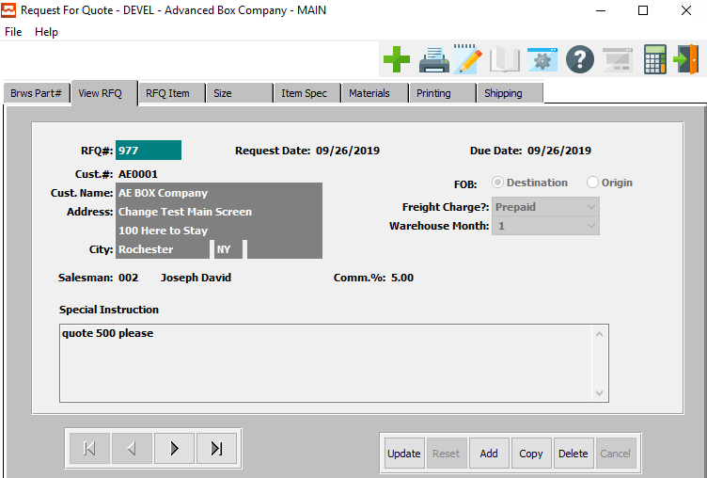

#### UPDATE

To change the currently selected Quote Request, simply click the ***“Update***” button at the bottom of the screen.

#### ADD

To add a new Quote Request, simply click the ***“Green + Icon”*** button at the top of the Quote Request screen.

Alternatively, click the ***“Add”*** button at the bottom of the screen.

#### COPY

Click the ***“Copy”*** button to copy information from the currently selected Quote Request.

#### DELETE

To delete the currently selected Quote Request, simply press the ***"D"*** key. Alternatively, click the ***“Delete”*** button at the bottom of the screen.

#### NEXT

Press ***"N"*** (Next) to find next Quote Request to view or modify. Alternatively, press the ***“Right Arrow”*** on the screen.

#### PREVIOUS

Press ***"P"*** (Previous) to find previous Quote Request to view or modify. Alternatively, press the ***“Left Arrow”*** on the screen.

### Add/Update RFQ

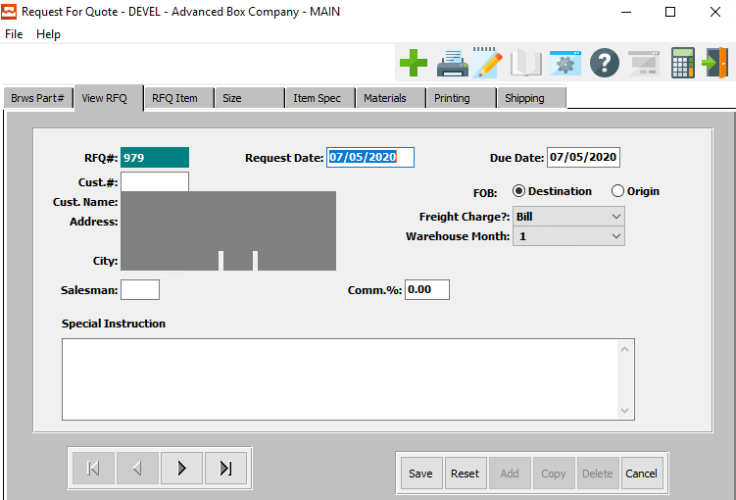

#### SAVE

Click the ***“Save”*** button to save all changes to the current Quote Request.

#### RESET

Click the ***“Reset”*** button to reset all fields to their original state.

#### CANCEL

Click the ***“Cancel”*** button to cancel all changes to the Quote Request without saving.

#### NEXT

Press ***"N"*** (Next) to find next Quote Request to view or modify. Alternatively, press the ***“Right Arrow”*** on the screen.

#### PREVIOUS

Press ***"P"*** (Previous) to find previous Quote Request to view or modify. Alternatively, press the ***“Left Arrow”*** on the screen.

### Add/Update RFQ Field Definitions

#### Request Date

Enter the request date of this quote. You can use the popup calendar by using the ***“F1”*** key to make your selection.

#### Due Date

Enter the due date for this quote request.

#### Customer #

Enter the customer number that is requesting the quote.

#### Customer Name and Address

The customer’s name and address will transfer from the customer file as soon as the user enters or chooses a valid customer number.

#### FOB (Choice)

To choose the preferred FOB option of Destination vs. Origin, please make sure the desired option choice bubble is toggled.

#### Freight Charge?

The user must choose the type of freight charge for this quote request from the drop-down list of available options.

Valid Freight Charge Options are as Follows:

|  |  |
| --- | --- |
| Bill | Prepaid |
| Collect | Third Party |

#### Warehouse Month

Enter a number between 1 and 12 to indicate which warehouse month is chosen.

#### Salesman

Enter salesman code who entered this order you can also use the pop-up menu by selecting the ***“F1”*** key.

#### Commission %

Enter the salesman commission rate for this order.

#### Special Instruction

If these are any special instructions for this quote request, the user may enter them in these fields.

## RFQ Item

### Overview

The RFQ item line is the only information required to create a request for quotation, however additional folders allow adding more detail specifications for the item. The RFQ item screen allows the user to add, change, delete, copy and transfer request for quotations. When adding a new item, multiple quantities may be added by pressing the ***“F1”*** function key.

On the quantity field Likewise the ***“F1”*** Key will provide a look up for the finished good item number, customer part number, style, product category and board material. The ***“TAB”*** key should be used to move from one field to the next field, whereas the ***“Shift” / “TAB”*** keys will move back one field at a time. The ***“Enter”*** key will act to save the item's record whether or not all the information for all the fields have been added or left blank.

When pressing the ***“F1”*** key to search for any information, a browser pertaining to that field will display, which will allow you to sort on various fields shown on the browser. To select an item from the browser list, simply double click with your mouse or use the ***“Arrow”*** keys to select an item then press the ***“Enter”*** key.

When creating locations for existing items which have been previously manufactured or previously estimated, the finished good item number or the customer part number will import all the specifications defined in the estimate immediately after entering the item number including the blank dimensions, board materials, ink colors, shipping carrier, packing materials and more. If the item number does not exist, the user can enter the information and later transfer this to a new estimate.

### RFQ Item Screen

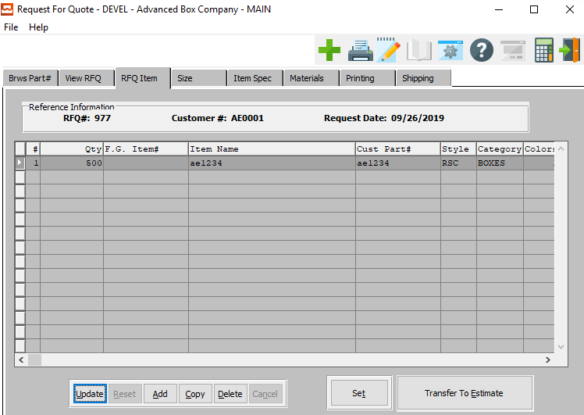

#### UPDATE

To change the currently selected Item, simply click the ***“Update***” button at the bottom of the screen.

#### ADD

Click the ***“Add”*** button at the bottom of the screen to add a new Item.

#### COPY

Click the ***“Copy”*** button to copy information from the currently selected Item.

#### DELETE

To delete the currently selected Item, simply press the ***"D"*** key. Alternatively, click the ***“Delete”*** button at the bottom of the screen.

#### SET

Click the ***“Set”*** button to view or update Set details.

#### TRANSFER TO ESTIMATE

Click the ***“Transfer to Estimate”*** button to transfer the currently selected item (and all of its attached parameters) to an estimate file.

### Add/Update RFQ Item

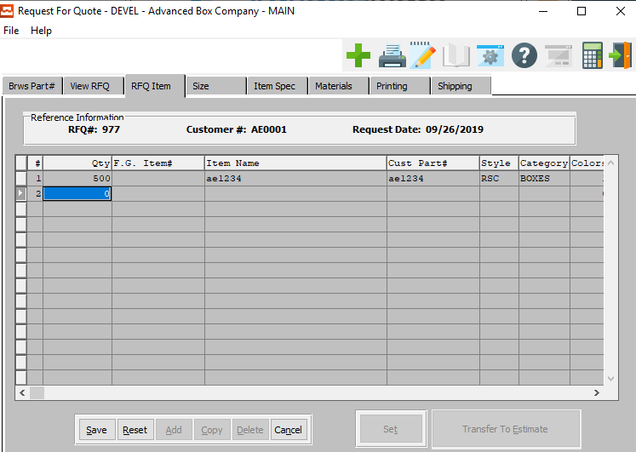

#### SAVE

Click the ***“Save”*** button to save all changes to the current Item.

#### RESET

Click the ***“Reset”*** button to reset all fields to their original state.

#### CANCEL

Click the ***“Cancel”*** button to cancel all changes to the Item without saving.

### Add/Update RFQ Item Field Definitions

#### Line #

The line number is automatically counted by the system, and cannot be modified by the user.

#### Quantity

Enter the quantity for this item.

#### FG Item #

Enter the Finished Good Item number on this line or you may use the ***“F1”*** key to make your selection from the list.

#### Item Name

Enter the item name on this line.

#### Customer Part #

Enter the customer part number for this item. Alternatively, press the ***“F1”*** key to choose an item from a list of available Customer Part numbers.

#### Style

Enter the Style Code for this item. Alternatively, press the ***“F1”*** key to choose a code from a list of available Style Codes.

#### Category

Enter the Category for this item. Alternatively, press the ***“F1”*** key to choose a category from a list of available Categories.

#### Colors

Enter the color number that you would like to use for this job.

#### Coating

Enter the coating number for this job.

#### Length

Enter the length of this item.

#### Width

Enter the width of this item.

#### Depth

Enter the depth of this item.

#### Board

Enter the board material that will be used for this job or you may us the ***“F1”*** key to do a look-up.

#### Caliper

Enter the caliper in this field.

### Set Information

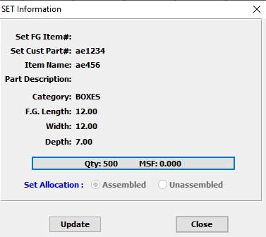

#### UPDATE

To change the currently selected Set Information, simply click the ***“Update***” button at the bottom of the screen.

#### CLOSE

Click the ***“Close”*** button to exit the Set Information popup screen.

### Update Set Information

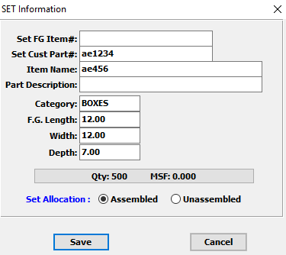

#### SAVE

Click the ***“Save”*** button to save all changes to the current Set Information.

#### CANCEL

Click the ***“Cancel”*** button to cancel all changes to the Set Information without saving.

### Update Set Information Field Definitions

#### Set FG Item #

Enter the Finished Good Item Number.

#### Set Customer Part #

Enter the Customer Part Number.

#### Item Name

Enter the Item Name.

#### Part Description

Enter the Part Description,

#### Category

Enter the category for this item. Alternatively, press the ***“F1”*** key to choose a category from a list of available categories.

#### F.G. Length

Enter the length of this Finished Good.

#### F.G. Width

Enter the width of this Finished Good.

#### F.G. Depth

Enter the depth of this Finished Good.

#### Set Allocation (Choice)

To choose the preferred set allocation of Assembled vs. Unassembled, please make sure the desired option choice bubble is toggled.

## Size

### Overview

The size folder works exactly like the blank dimensions, which are calculated in the estimating program. Once the style code has been defined along with the carton's length, width and depth, the program will import the joint or glue lap material; default carton dimensions and immediately calculates the blank width, blank length and blank square inches.

Update or change any dimensions for the box, simply press the ***“Update”*** key, then change any dimension including the blank length or blank width. If you want the program to utilize the formulas defined in the style file to calculate the blank length and width, press the ***“Auto Calculate”*** button. When finished updating the record, press the ***“Save”*** Key or the ***“Enter”*** Key.

### Size Screen

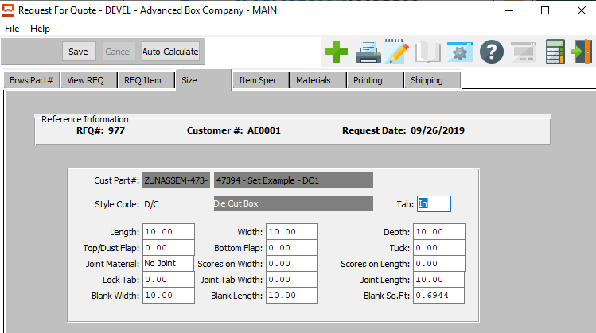

#### SAVE

Click the ***“Save”*** button to save all changes to the current Size.

#### AUTO-CALCULATE

Click the ***“Auto-Calculate”*** button to automatically calculate all prices for this item based on the most-current measurements.

### Size Field Definitions

#### Tab

Enter ***“I”*** for ‘In’, or ***“O”*** for ‘Out’. The ***“Tab”*** key in combination with the flute code and style code will determine the blank length, width, square feet, number up on the layout, die size and sheet size.

#### Length / Width / Depth

Enter the length, width, and depth of this item.

#### Top/Dust Flap

Enter the measurement of the top/dust flap of the box.

#### Bottom Flap

Enter the measurement of the bottom flap of the box.

#### Tuck

Enter the measurement of the tuck of this box.

#### Joint Material

Enter the joint material of this box. Alternatively, press the ***“F1”*** key to choose a material from a list of valid Joint Materials.

#### Scores on Width

Enter the number of scores along the width of this box.

#### Scores on Length

Enter the number of scores along the length of this box.

#### Lock Tab

Enter the measurement of the lock tab of this box.

#### Joint Tab Width

Enter the measurement of the joint tab width of this box.

#### Joint Length

Enter the measurement of the joint tab length of this box.

#### Blank Width

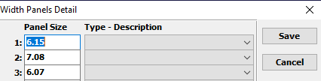

The user may enter as many blank widths as necessary for this box.

#### Blank Length

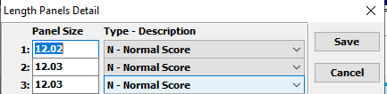

The user may enter as many blank lengths as necessary for this box.

#### Blank Square Feet

Enter the measurement of the blank square feet of this box.

## Item Specification

### Overview

The item specification folder allows definition of item specific information such as the item name part, description, product category, finished good item number, plate number, die number, CAD number, UPC number and quality control number.

This information will import automatically when an existing part number has been entered on the item folder, otherwise this information may be added at any time for a brand-new item which is to be quoted. To update this information, press the ***“Update”*** button and ***“Tab”*** to the field or use your mouse to click in the field.

### Item Spec Screen

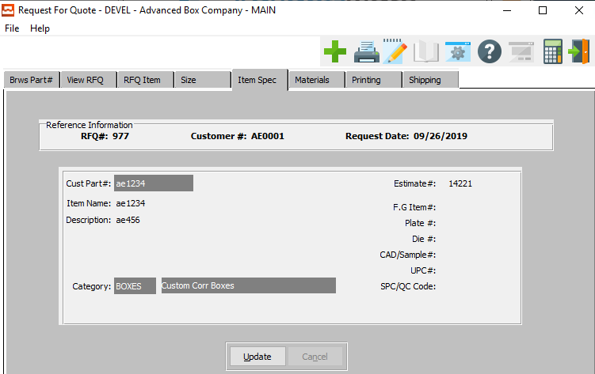

#### UPDATE

To change the currently selected Item Specification, simply click the ***“Update***” button at the bottom of the screen.

### Update Item Spec

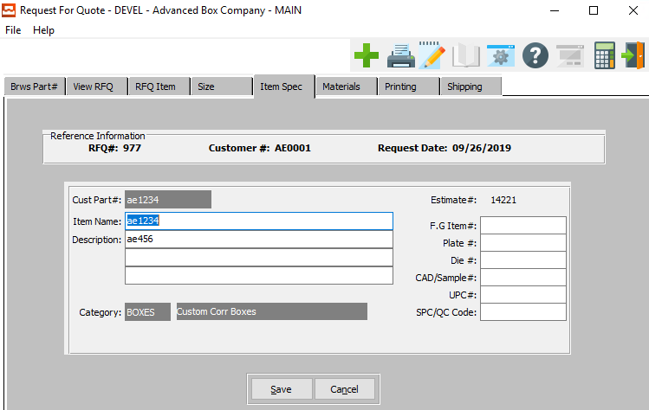

#### SAVE

Click the ***“Save”*** button to save all changes to the current Item Specification.

#### CANCEL

Click the ***“Cancel”*** button to cancel all changes to the Item Specification without saving.

### Update Item Spec Field Definitions

#### Item Name / Item Description

Enter the item name on this line. Enter the description on this line. The user may use up to three lines for the item description.

#### FG Item #

Enter the Finished Good Item number on this line or you may use the ***“F1”*** key to make your selection from the list.

#### Plate #

Enter the plate number or use the ***“F1”*** Key to do a look up from the list.

#### Die #

Enter the die number that you would like to use for this job. You can us the look up menu by pressing the ***“F1”*** Key.

#### CAD/Sample #

Enter the Cad sample number for this job. Use the ***“F1”*** for a look-up.

#### UPC #

Enter the UPC number of the job. Use the ***“F1”*** Key for a look-up.

#### SPC/QC Code

Enter the SPC/QC Code for this job. You can use the ***“F1”*** for a look-up.

## Materials

### Overview

The materials folder is a screen that concentrates all the materials required for an item, including paper board, tape, staples, window film, wax, foil stamping, lamination and miscellaneous materials. The dimensions of each material may be defined in this area, otherwise the estimating person may make the appropriate changes later.

When pressing the ***“F1”*** button on each material field, a browser pertaining to that particular material will show a list of all the existing material in the Advantzware database. Each browser provides different sort options for the fields listed on the browser screen. Any changes made to this screen will transfer are to the estimate. When finished updating, press the ***“Enter”*** key or the ***“Save”*** key.

### Materials Screen

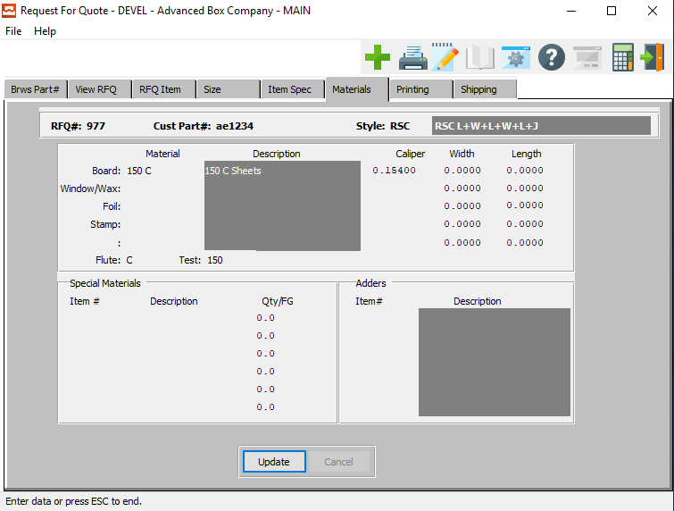

#### UPDATE

To change the currently selected Material, simply click the ***“Update***” button at the bottom of the screen.

### Update Materials

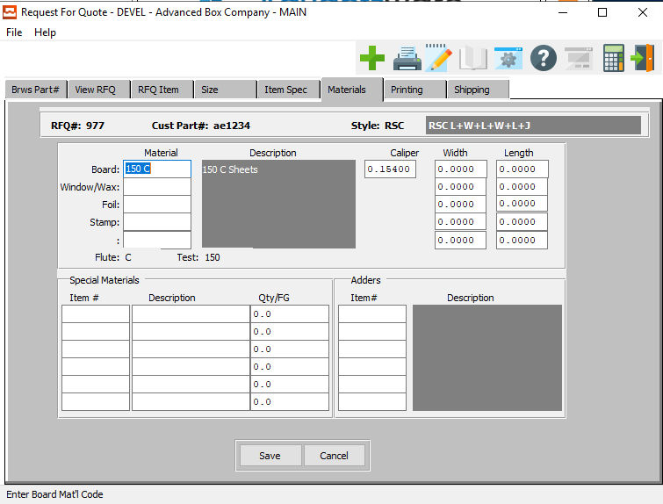

#### SAVE

Click the ***“Save”*** button to save all changes to the current Material.

#### CANCEL

Click the ***“Cancel”*** button to cancel all changes to the Material without saving.

### Update Materials Field Definitions

#### Board

Enter the board material that will be used for this job or you may us the ***“F1”*** Key to do a look-up.

#### Window/Wax

Enter the window or wax that will be used for this job. Us the ***“F1”*** Key for a look-up.

#### Foil

Enter the Foil that will be used for this job. Us the ***“F1”*** Key for a look-up.

#### Stamp

Enter the Stamp that will be used for this job. Us the ***“F1”*** Key for a look-up.

#### Caliper

Enter the Caliper that will be used for this job. Us the ***“F1”*** Key for a look-up.

#### Width

Enter the width.

#### Length

Enter the length.

#### Special Materials: Item #

Enter the number for the special material that will be used for this job. You can us the ***“F1”*** Key for a look-up on the pop-up menu.

#### Special Materials: Description

Enter the description for the materials.

#### Special Materials: Qty/FG

Enter the number of pieces of this material required to make one finished goods item. The cost is defined in the materials vendor cost matrix.

#### Adders: Item #

Enter the item number in this field.

## Printing

### Overview

The printing folder will list all the ink colors and coatings for each part number as well as the coverage percentage for each material. When creating a new item, the number of colors entered on the item folder will automatically create a separate ink color on this screen. Likewise, existing part numbers will import the items colors and coatings from the original estimate as defined in the finished goods item file in the Advantzware database.

The ink and coatings material defined in the control file will be utilized as a default material shown on this screen. To update with actual ink material defined in the Advantzware database, press the ***“F1”*** key, which will then show a browser of all available ink material.

To select a material from the browser screen, use the ***“Arrow”*** key to move to on change color then press the ***“Enter”*** key, otherwise you may use your mouse to select the item and double click the highlighted material. When finished updating, press the ***“Enter”*** key or the ***“Save”*** key.

### Printing Screen

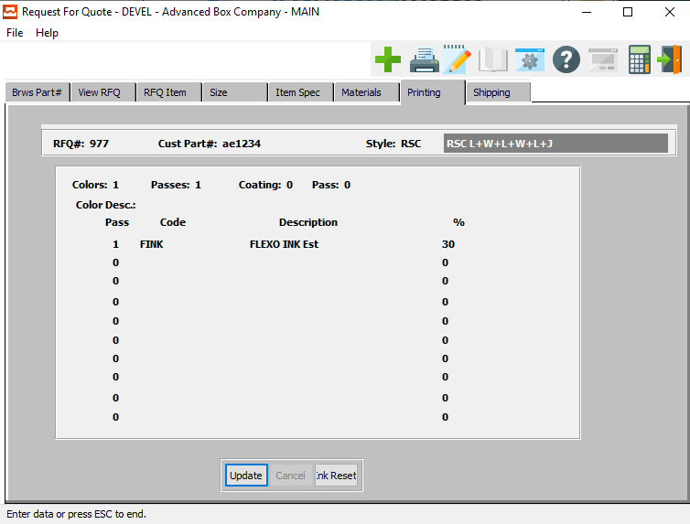

#### UPDATE

To change the currently selected Printing Option, simply click the ***“Update***” button at the bottom of the screen.

#### INK RESET

Click the ***“Ink Reset”*** button to reset all fields to their original state.

### Update Printing Information

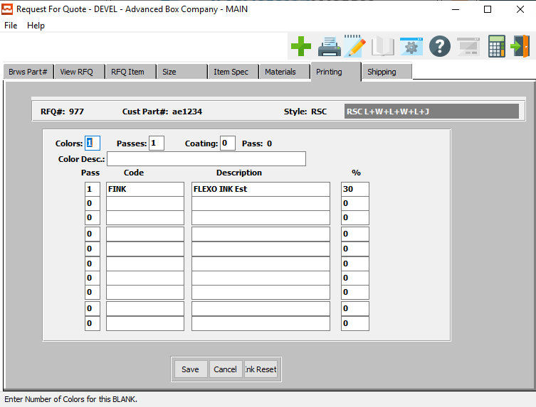

#### SAVE

Click the ***“Save”*** button to save all changes to the current Printing Option.

#### CANCEL

Click the ***“Cancel”*** button to cancel all changes to the Printing Option without saving.

#### INK RESET

Click the ***“Ink Reset”*** button to reset all fields to their original state.

### Update Printing Information Field Definitions

#### Colors

Enter the color number that you would like to use for this job.

#### Passes

Enter on how many passes it will take to complete the job.

#### Coating

Enter the coating number for this job.

#### Color Description

Enter the color description of this job.

#### Pass #

Enter the pass number in this field.

#### Pass Code

Enter the code in this field.

#### Pass Description

Enter the description in this field.

#### Pass %

The percentage defaults from the style file.

## Shipping

### Overview

The shipping folder defines in the common carrier or trucking company for shipping the finished goods as well as defining the packing information such as quantity per bundle, quantity per corrugated case, number of bundles or cases per pallet and the total quantity per pallet.

The packing material including the bundle, corrugated case and pallet size will transfer from the customer file or the control file respectively. The length, width and depth will transfer from the raw material file in the Advantzware for database; otherwise this may be entered directly on this screen. The system will automatically calculate the quantity per pallet, or this may be manually entered.

The ***“Update”*** button provides the ability to change the packing material while simultaneously calculating the quantity per pallet and number of bundles or cases per pallet. The number of boxes packed per case for bundle may be calculated by either a predetermined quantity or by the predetermined weight limit of the bundle or corrugated case.

The customer may specify the exact number of boxes per bundle or per case and how many of these units per pallet. Likewise, the customer may specify a pallet size which limits the height of the shipping pallet so that the boxes will fit in their storage racks. Therefore, the number of boxes per pallet multiplied by the number of bundles or cases per pallet equal the total quantity per pallet.

When utilizing corrugated cases to pack the boxes, a maximum weight per case may be used so that the total number of boxes per case is determined by calculating the total weight for the total quantity estimated which is divided by the weight per case.

The ***“Update”*** button allows the manual entry of the quantity per case or quantity per bundle and the number of bundles or cases per pallet, which yields the total quantity per pallet.

### Shipping Screen

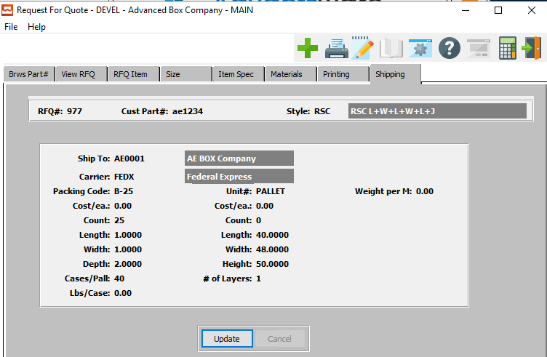

#### UPDATE

To change the currently selected Shipping Option, simply click the ***“Update***” button at the bottom of the screen.

### Update Shipping

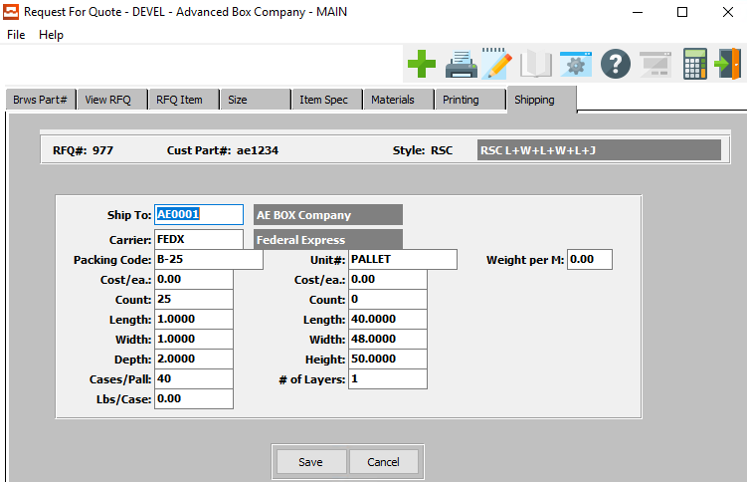

#### SAVE

Click the ***“Save”*** button to save all changes to the current Shipping Option.

#### CANCEL

Click the ***“Cancel”*** button to cancel all changes to the Shipping Option without saving.

### Update Shipping Field Definitions

#### Ship-To

Enter the ship-to name. You can use the ***“F1”*** to do a look-up.

#### Carrier

Enter the carrier. You can do a ***“F1”*** look-up on a list of carriers.

#### Packing Code

Enter the packing code or you may use the ***“F1”***] to do a look-up.

#### Packing: Cost/Each

Enter the cost of each.

#### Packing: Count

Enter the count amount.

#### Packing: Length / Width / Depth

Enter the length, width, and depth of the box.

#### Packing: Cases/Pallet

Enter the cases number.

#### Packing: Pounds/Case

If the number of cases per pallet on the estimate is zero, then the total number of pallets required is calculated by dividing the total shipping weight by the weight per pallet.

#### Unit #

Enter the unit number or you may use the ***“F1”*** look-up key.

#### Units: Cost/Each

Enter the cost of each item.

#### Units: Count

Enter the count.

#### Units: Length

Enter the length.

#### Units: Width

Enter the width.

#### Units: Height

Enter the height.

#### Units: # of Layers

Enter the number of layers that will be used.

#### Weight per M

Add the weight per M.

# **Line Request for Quotes [QL]**

## Overview

To print one or more request for quotations, press the reports menu selection and enter the customer range or the request for quote number range, then press the ***“Next”*** button to print the request for quotation report. When printing the report for many quotations, the report will list each item's customer part number, the item name, the style of the box, the product category, the carton length, width and depth, as well as the customer code, customer name and the required date.

When printing this report, you should select the font size of eight characters per inch. When printing a single request for quotation, more detail information will print then when printing range of quotes together.

## Single RFQ List [QL1]

### Selection Parameters

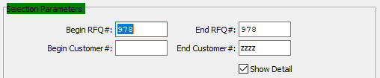

#### Begin RFQ # / End RFQ #

Enter the beginning and ending Request for Quote Number to run the report for.

#### Begin Customer # / End Customer #

Enter the beginning and ending Customer Number to run the report for.

#### Show Detail – Toggle Box

To show detailed items and customers on the report, make sure that the Show Detail toggle box is checked.

### Output Destination

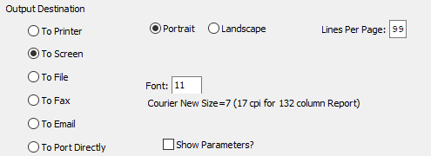

#### Destination Choice

To choose the destination where the document should be printed, please make sure that desired output destination choice bubble is toggled.

#### Layout Choice

To choose the preferred layout of Landscape vs. Portrait, please make sure the desired option choice bubbled is toggled.

#### Lines Per Page

Lines per page on the report when printing.

#### Font

Enter the font number to use with this report (Font 11 is default).

#### Show Parameters? – Toggle Box

To show parameters, make sure that the toggle box is ‘ticked’ with a checkmark.

## RFQ List [QL2]

### Selection Parameters

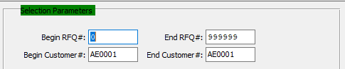

#### Begin RFQ # / End RFQ #

Enter the beginning and ending Request for Quote Number to run the report for.

#### Begin Customer # / End Customer #

Enter the beginning and ending Customer Number to run the report for.

### Output Destination

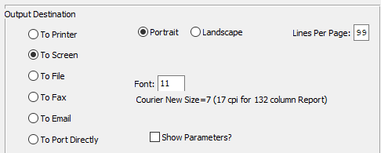

#### Destination Choice

To choose the destination where the document should be printed, please make sure that desired output destination choice bubble is toggled.

#### Layout Choice

To choose the preferred layout of Landscape vs. Portrait, please make sure the desired option choice bubbled is toggled.

#### Lines Per Page

Lines per page on the report when printing.

#### Font

Enter the font number to use with this report (Font 11 is default).

#### Show Parameters? – Toggle Box

To show parameters, make sure that the toggle box is ‘ticked’ with a checkmark.

# **File Maintenance for RFQ [QF]**

## Overview

The control file maintenance screen provides default information when adding new part numbers into the request for quotation module. This screen is very similar to the estimating control file defined in Advantzware. The user may define the starting request for quotation number and a valid range of numbers to be utilized by the system. Likewise, materials such as corrugated cases, bundles, inks, coatings and pallet may be defined in this file.

To save the information added to this file press the ***“Save”*** button or press the ***“Enter”*** key. When entering an item part number that exists in the Advantzware database, the data control file will not be used because the data will transfer directly from the estimate file from the Advantzware database.

## RFQ File Maintenance [QF1]

### Overview

The control file maintenance screen provides default information when adding new part numbers into the request for quotation module. This screen is very similar to the estimating control file defined in Advantzware. The user may define the starting request for quotation number and a valid range of numbers to be utilized by the system.

Likewise, materials such is corrugated cases, bundles, inks, coatings and pallet may be defined in this file. To save the information added to this file press the ***“Save”*** button or press the ***“Enter”*** key. When entering an item part number that exists in the Advantzware database, the data control file will not be used because the data will transfer directly from the estimate file from the Advantzware database.

### RFQ Maintenance Screen

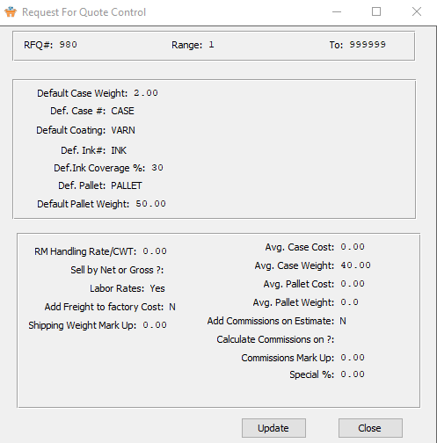

#### UPDATE

To change the Quote Request Control, simply click the ***“Update***” button at the bottom of the screen.

#### CLOSE

Click the ***“Close”*** button to exit the Control popup screen.

### Update RFQ File Maintenance

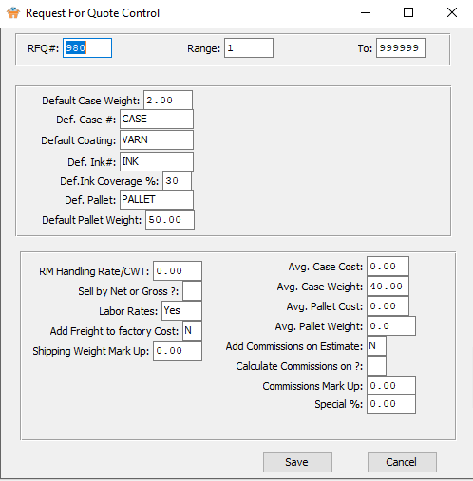

#### SAVE

Click the ***“Save”*** button to save all changes to the Maintenance Control.

#### CANCEL

Click the ***“Cancel”*** button to cancel all changes to the Control screen without saving.

### Update RFQ File Maintenance Field Definitions

#### RFQ #

Enter the chosen first RFQ number to assign the next new Quote Request to.

#### Range / To

Enter the beginning and ending range of available quote requests in the system.

#### Default Case Weight

Enter the default case weight for all new cases.

#### Default Case #

To speed estimating, this material transfers to each estimate if not defined by style. The number of cases required is calculated by either case count or by weight per case, as defined in the cases raw material record. Given the case count, the estimate quantity is divided by the case count.

Alternatively, if we use weight per case, the system calculates the total shipping weight for the run quantity and divides by the weight per case. Given the number of cases, the program finds the cost per case in the case materials matrix and multiplies by the total number of cases.

#### Default Coating

To speed estimating, this coating item number will transfer to each new estimate if not defined in the style file. When the number of coatings is entered on the estimate, this coating number will repeat for the number of coating entered. This may be changed.

#### Default Ink #

To speed estimating, this material item number will transfer to each new estimate if not defined in the style file. When the number of colors is entered on the estimate, this item number will be duplicated by the amount of colors.

#### Default Ink Coverage %

To speed estimating, this coverage percentage automatically transfers to each color on the estimate. Alternatively, an ink may be assigned for each style.

#### Default Pallet

To speed estimating, this material item transfers to each estimate if not defined by style. If a case number is entered, the number of pallets is calculated as dictated by the cases per pallet in the materials case record.

The system calculates the total number of pallets and multiplies by the cost per pallet. If the cases per pallet is zero on the estimate, the number of pallets will be calculated by the Weight per Pallet. For freight calculations, a pallet weighs 50 pounds.

#### Default Pallet Weight

If the number of cases per pallet on the estimate is zero, then the total number of pallets required is calculated by dividing the total shipping weight by the weight per pallet.

#### RM Handling Rate/CWT

Enter the default Raw Material Handling Rate for all new quote requests.

#### Sell by Net or Gross?

Enter the default sell by option for all new quote requests. Enter an ***“N”*** for ‘Net’, or a ***“G”*** for ‘Gross’.

#### Labor Rates

Enter the default labor rate option for all new quote requests. Enter a ***“Y”*** for ‘Yes, or an ***“N”*** for ‘No.

#### Add Freight to Factory Cost

Enter the default option for all new quote requests. Enter a ***“Y”*** for ‘Yes, or an ***“N”*** for ‘No.

#### Shipping Weight Mark Up

Enter the default shipping weight mark up for all new quote requests.

#### Average Case Cost

Enter the default average case cost for all new quote requests.

#### Average Case Weight

Enter the default average case weight for all new quote requests.

#### Average Pallet Cost

Enter the default average pallet cost for all new quote requests.

#### Average Pallet Weight

Enter the default average pallet weight for all new quote requests.

#### Add Commissions On Estimate

Enter ***"Y"*** for yes or ***"N"*** for no to add the commissions in the estimate.

#### Calculate Commissions On?

Enter the default calculating commissions option for all new quote requests. Enter a ***“Y”*** for ‘Yes, or an ***“N”*** for ‘No.

#### Commissions Mark Up

Enter the percentage to multiple by total cost to calculate commissions for an estimate if not defined in the salesman file. Commissions set up in the salesman file may be established by customer, customer type and category. This cost is added to the full cost.

#### Special %

Enter the default special percentage for all new quote requests.